**Practical No 2 Roll no:-29**

* **Simple hello world application program**
* **INPUT**

***(MainActivity.kt)***

package com.example.helloworld  
  
import androidx.appcompat.app.AppCompatActivity  
import android.os.Bundle  
  
class MainActivity : AppCompatActivity() {  
 override fun onCreate(savedInstanceState: Bundle?) {  
 super.onCreate(savedInstanceState)  
 setContentView(R.layout.*activity_main*)  
 }  
}

***(activity_main.xml)***

*<?*xml version="1.0" encoding="utf-8"*?>*<androidx.constraintlayout.widget.ConstraintLayout xmlns:android="http://schemas.android.com/apk/res/android"  
 xmlns:app="http://schemas.android.com/apk/res-auto"  
 xmlns:tools="http://schemas.android.com/tools"  
 android:layout_width="match_parent"  
 android:layout_height="match_parent"  
 tools:context=".MainActivity">  
  
 <TextView  
 android:layout_width="213dp"  
 android:layout_height="103dp"  
 android:text="Hello World!"  
 android:textAlignment="center"  
 android:textAppearance="@style/TextAppearance.AppCompat.Large"  
 android:textSize="34sp"  
 app:layout_constraintBottom_toBottomOf="parent"  
 app:layout_constraintEnd_toEndOf="parent"  
 app:layout_constraintHorizontal_bias="0.444"  
 app:layout_constraintStart_toStartOf="parent"  
 app:layout_constraintTop_toTopOf="parent"  
 app:layout_constraintVertical_bias="0.369" />  
  
</androidx.constraintlayout.widget.ConstraintLayout>

* **OUTPUT (Virtual device)**

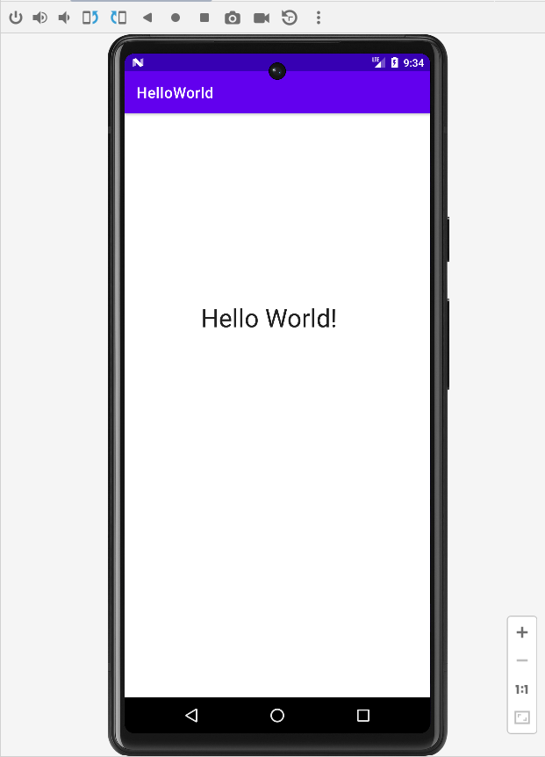

* **Activity life cycle**
* **INPUT**

package com.example.activitylifecycle  
  
import androidx.appcompat.app.AppCompatActivity  
import android.os.Bundle  
import android.util.Log  
  
class MainActivity : AppCompatActivity() {  
 var tag:String="Activity_Event"  
 override fun onCreate(savedInstanceState: Bundle?) {  
 super.onCreate(savedInstanceState)  
 setContentView(R.layout.*activity_main*)  
 Log.d(tag,"..onCreateoccured..")  
 }  
  
 override fun onStart() {  
 super.onStart()  
 Log.d(tag,"..onStartoccured..")  
 }  
  
 override fun onRestart() {  
 super.onRestart()  
 Log.d(tag,"..onRestartoccured..")  
 }  
  
 override fun onResume() {  
 super.onResume()  
 Log.d(tag,"..onResumeoccured..")  
 }  
  
 override fun onPause() {  
 super.onPause()  
 Log.d(tag,"..onPauseoccured..")  
 }  
  
 override fun onStop() {  
 super.onStop()  
 Log.d(tag,"..onStopoccured..")  
 }  
 override fun onDestroy() {  
 super.onDestroy()  
 Log.d(tag,"..onDestroyoccured..")  
 }  
}

***(activity_main.xml)***

*<?*xml version="1.0" encoding="utf-8"*?>*<androidx.constraintlayout.widget.ConstraintLayout xmlns:android="http://schemas.android.com/apk/res/android"  
 xmlns:app="http://schemas.android.com/apk/res-auto"  
 xmlns:tools="http://schemas.android.com/tools"  
 android:layout_width="match_parent"  
 android:layout_height="match_parent"  
 tools:context=".MainActivity">  
  
 <TextView  
 android:id="@+id/TextView1"  
 android:layout_width="266dp"  
 android:layout_height="89dp"  
 android:layout_marginStart="24dp"  
 android:layout_marginTop="140dp"  
 android:layout_marginEnd="24dp"  
 android:text="Welcome"  
 android:textAlignment="center"  
 android:textAppearance="@style/TextAppearance.AppCompat.Large"  
 android:textSize="34sp"  
 android:textStyle="normal|bold"  
 app:layout_constraintEnd_toEndOf="parent"  
 app:layout_constraintHorizontal_bias="0.496"  
 app:layout_constraintStart_toStartOf="parent"  
 app:layout_constraintTop_toTopOf="parent" />  
  
 <TextView  
 android:id="@+id/TextView2"  
 android:layout_width="263dp"  
 android:layout_height="78dp"  
 android:layout_marginStart="24dp"  
 android:layout_marginTop="44dp"  
 android:layout_marginEnd="24dp"  
 android:text="Study of Activity Life Cycle"  
 android:textAlignment="center"  
 android:textAppearance="@style/TextAppearance.AppCompat.Body2"  
 android:textSize="20sp"  
 app:layout_constraintEnd_toEndOf="parent"  
 app:layout_constraintStart_toStartOf="parent"  
 app:layout_constraintTop_toBottomOf="@+id/TextView1" />  
  
</androidx.constraintlayout.widget.ConstraintLayout>

* **OUTPUT**

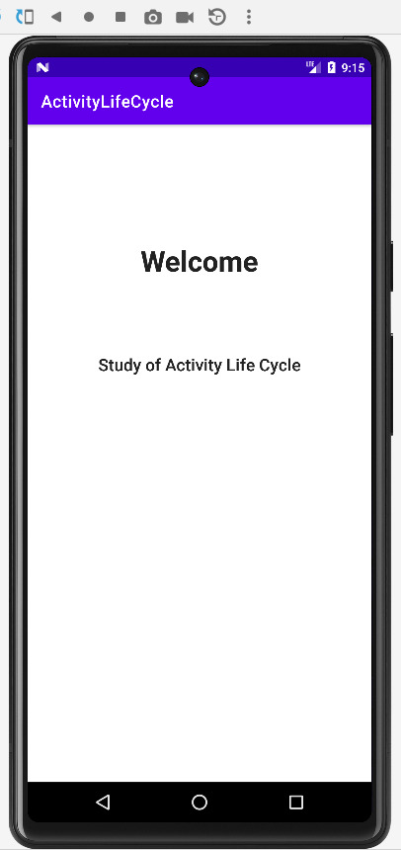



**After minimize our application (onPause() occurred)**

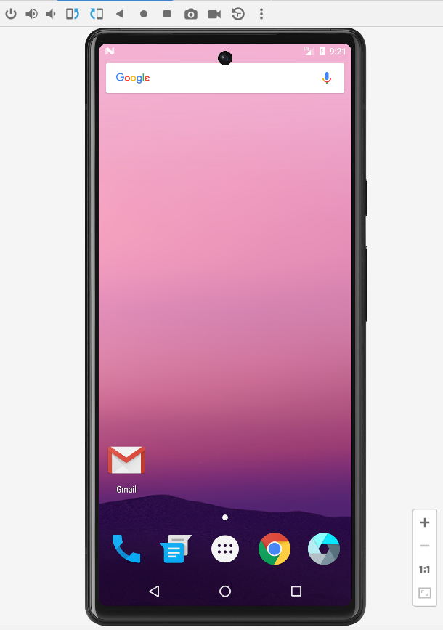



**After close our application(onStop() and onDestroy () occurred)**



